SCHOOL OF COMPUTER SCIENCE AND ARTIFICIAL INTELLIGENCE |  |  |  | DEPARTMENT OF COMPUTER SCIENCE ENGINEERING
Program Name: B. Tech |  |  | Assignment Type: Lab |  |  | Academic Year:2025-2026
Course Coordinator Name |  |  | Dr. Rishabh Mittal
CourseCode |  | 23CS002PC304 | Course Title |  | AI Assisted Coding
Year/Sem |  | III/II | Regulation |  | R23
Date and Day  of Assignment |  | Week6 – Monday | Time(s) |  | 23CSBTB01 To 23CSBTB52
Name |  | Numera Mahveen | Hallticket |  | 2303A54061
Assignment Number: 11.1(Present assignment number)/24(Total number of assignments)
 | Q.No. | Question |  |  |  |  | Expected Time  to complete
 | 1 | Lab 11 – Data Structures with AI: Implementing Fundamental Structures  Lab Objectives  - Use AI to assist in designing and implementing fundamental data structures in Python.  - Learn how to prompt AI for structure creation, optimization, and documentation.  - Improve understanding of Lists, Stacks, Queues, Linked Lists, Trees, Graphs, and Hash Tables.  - Enhance code quality with AI-generated comments and performance suggestions.  Task Description #1 – Stack Implementation  Task: Use AI to generate a Stack class with push, pop, peek, and is_empty methods.  Sample Input Code:  class Stack:  pass  Expected Output:  - A functional stack implementation with all required methods and docstrings.  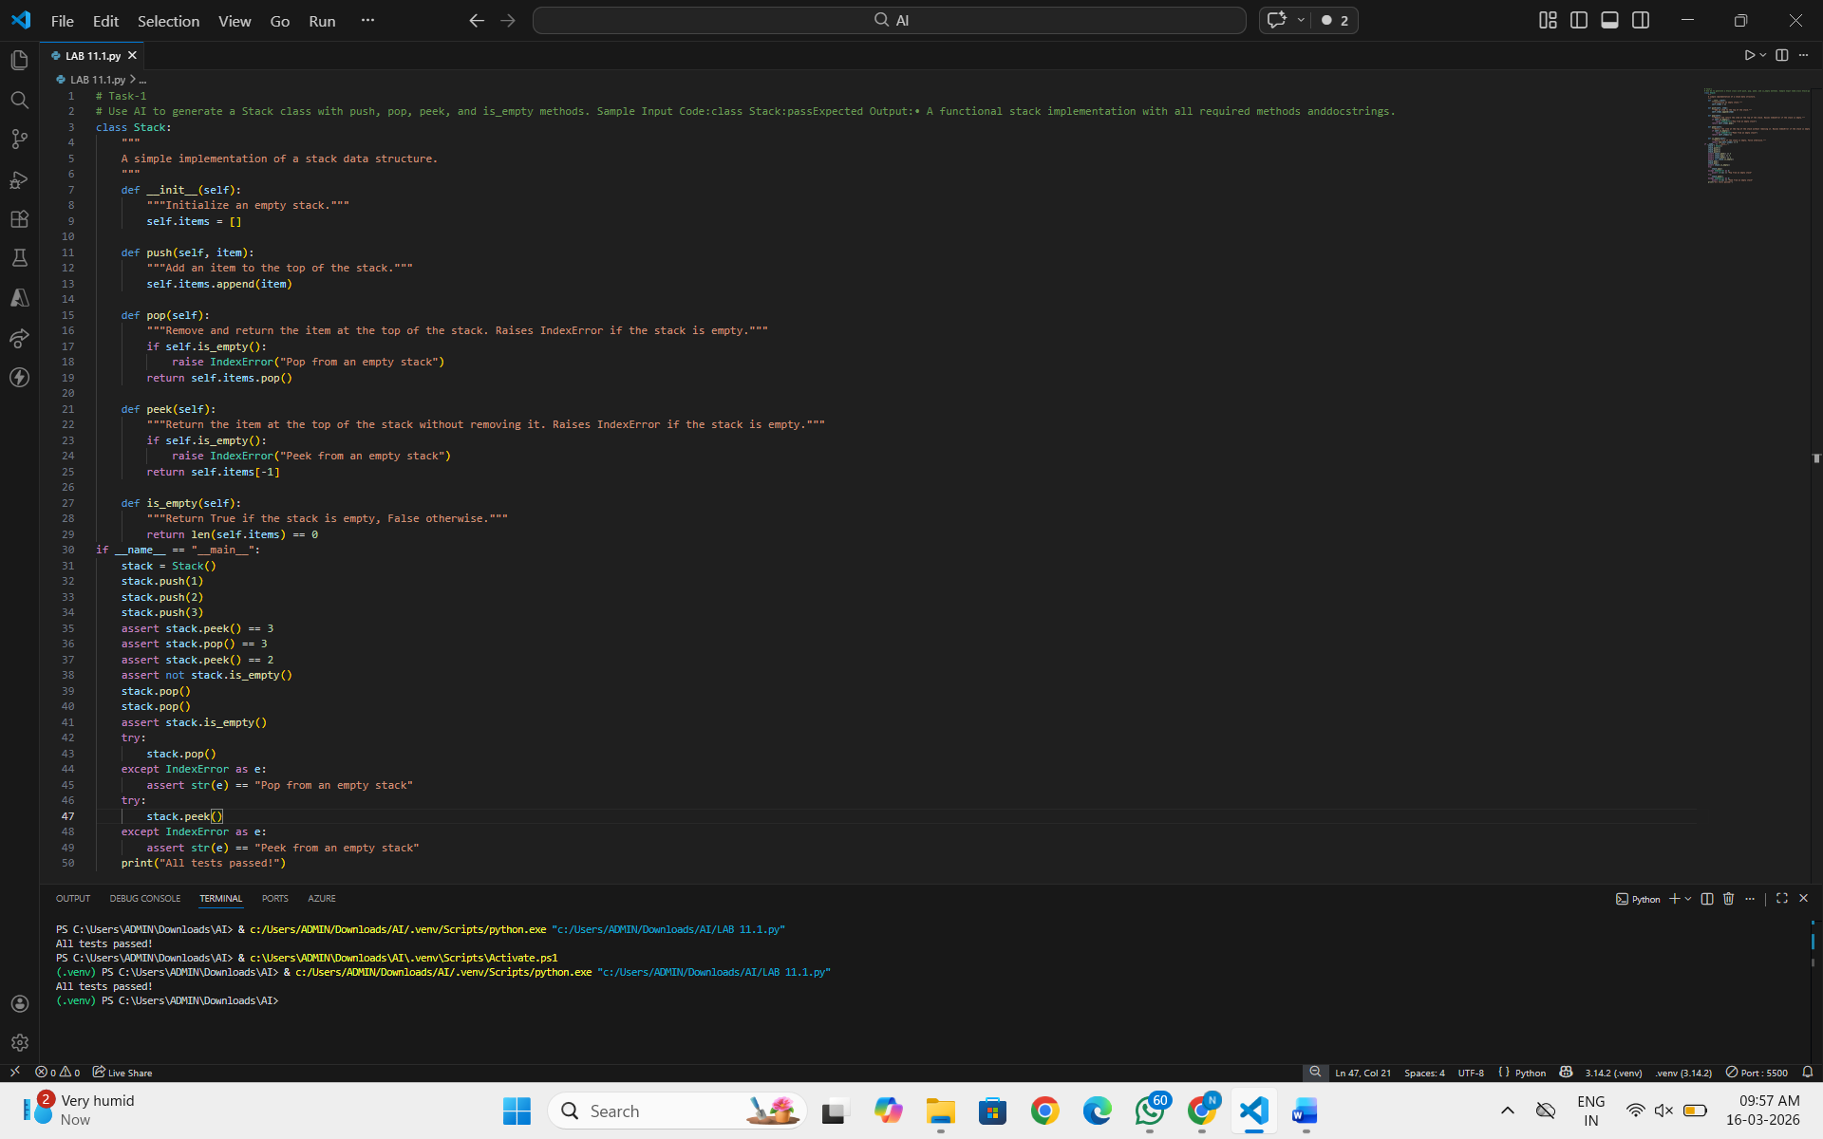  Task Description #2 – Queue Implementation  Task: Use AI to implement a Queue using Python lists.  Sample Input Code:  class Queue:  pass  Expected Output:  - FIFO-based queue class with enqueue, dequeue, peek, and size methods.  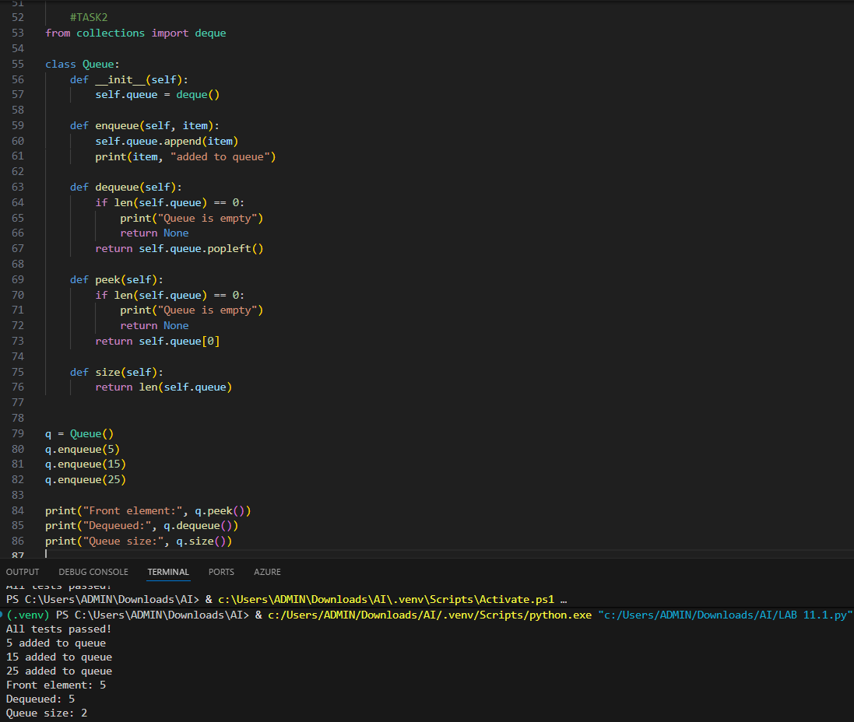  Task Description #3 – Linked List  Task: Use AI to generate a Singly Linked List with insert and display methods.  Sample Input Code:  class Node:  pass  class LinkedList:  pass  Expected Output:  - A working linked list implementation with clear method documentation.  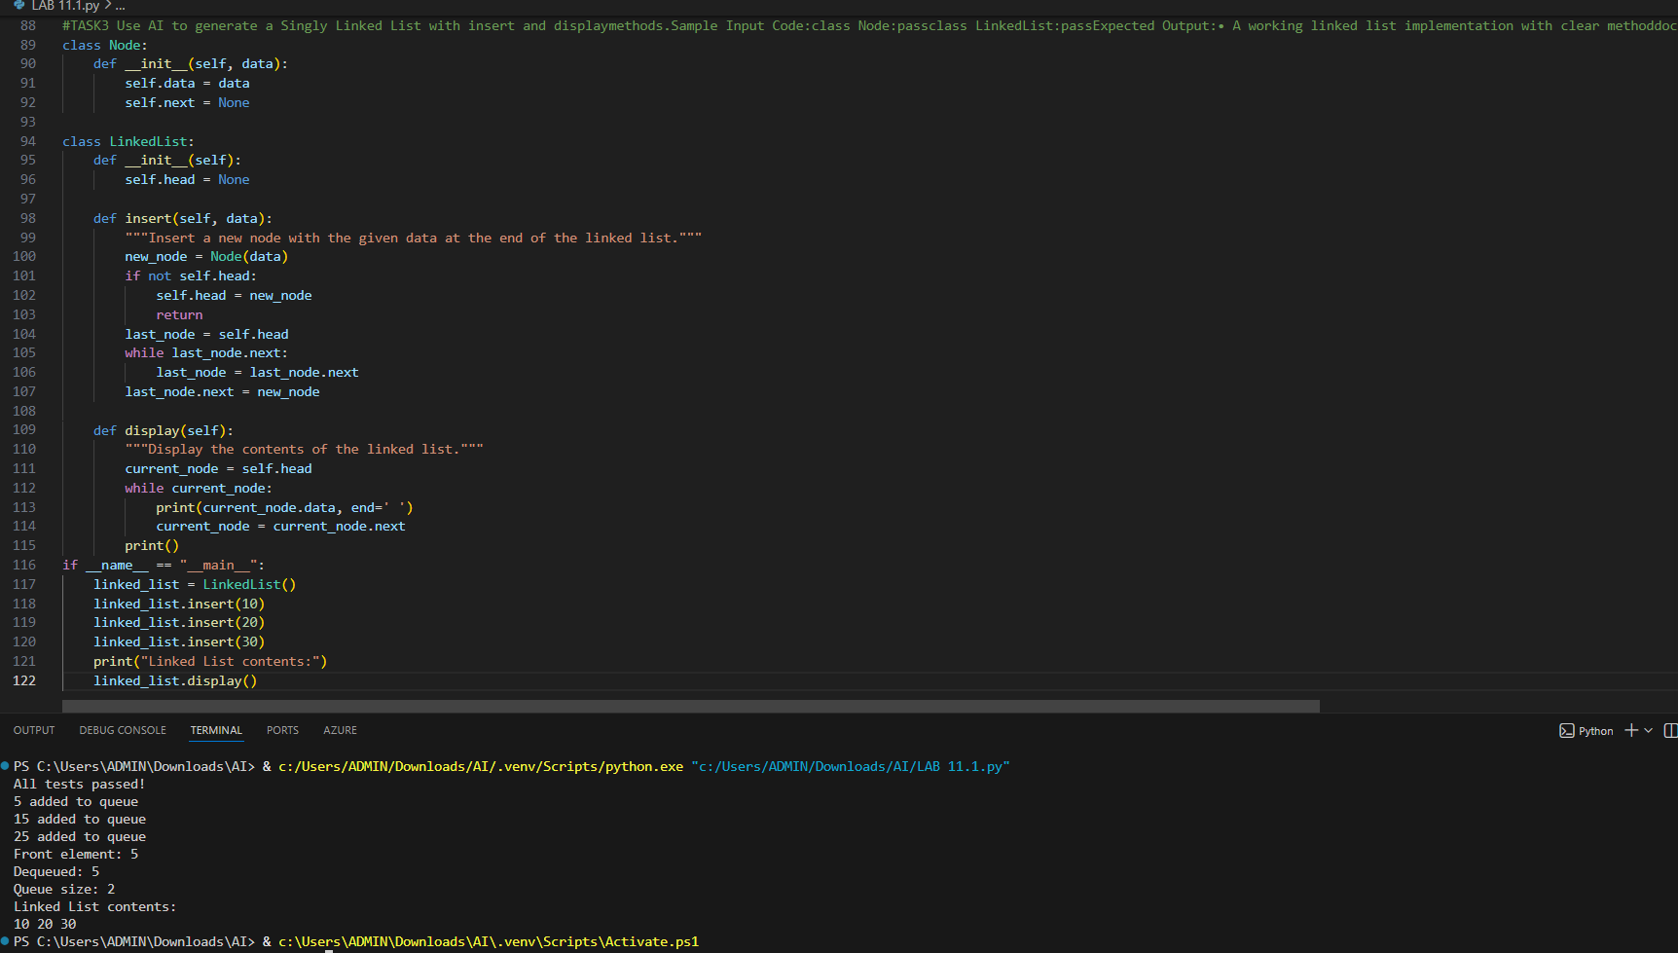  Task Description #4 – Binary Search Tree (BST)  Task: Use AI to create a BST with insert and in-order traversal methods.  Sample Input Code:  class BST:  pass  Expected Output:  - BST implementation with recursive insert and traversal methods.  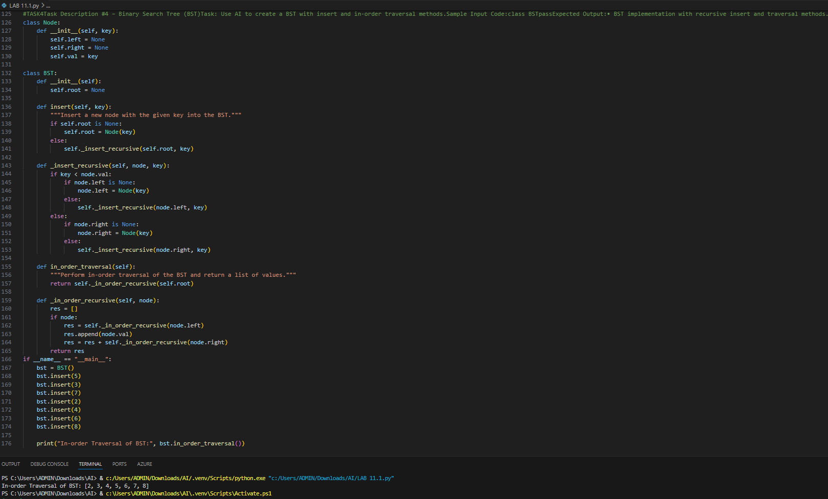  Task Description #5 – Hash Table  Task: Use AI to implement a hash table with basic insert, search, and delete methods.  Sample Input Code:  class HashTable:  pass  Expected Output:  - Collision handling using chaining, with well-commented methods.  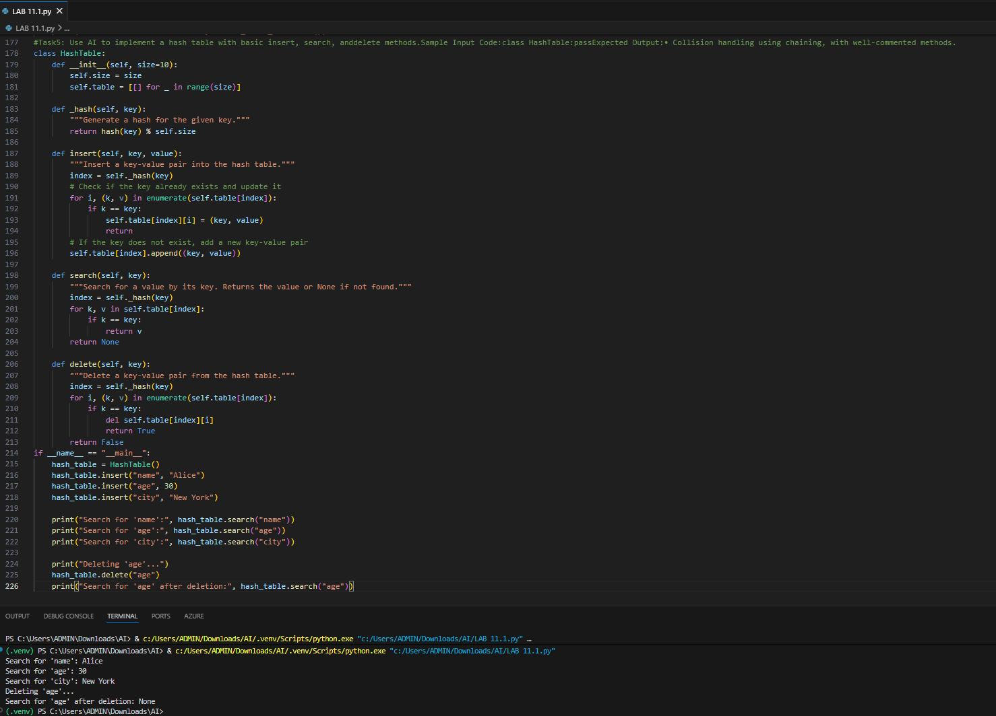  Task Description #6 – Graph Representation  Task: Use AI to implement a graph using an adjacency list.  Sample Input Code:  class Graph:  pass  Expected Output:  - Graph with methods to add vertices, add edges, and display connections.  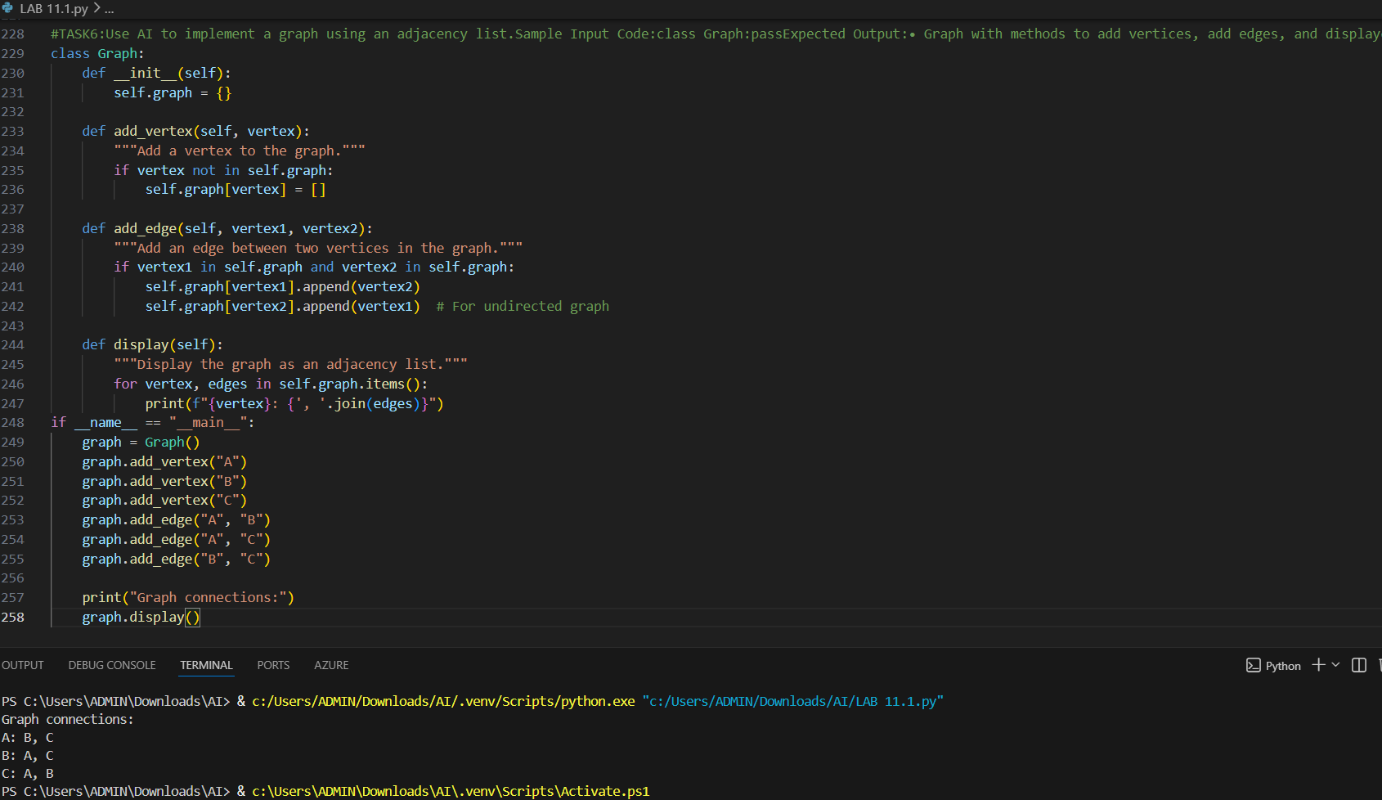  Task Description #7 – Priority Queue  Task: Use AI to implement a priority queue using Python’s heapq module.  Sample Input Code:  class PriorityQueue:  pass  Expected Output:  - Implementation with enqueue (priority), dequeue (highest priority), and display methods.  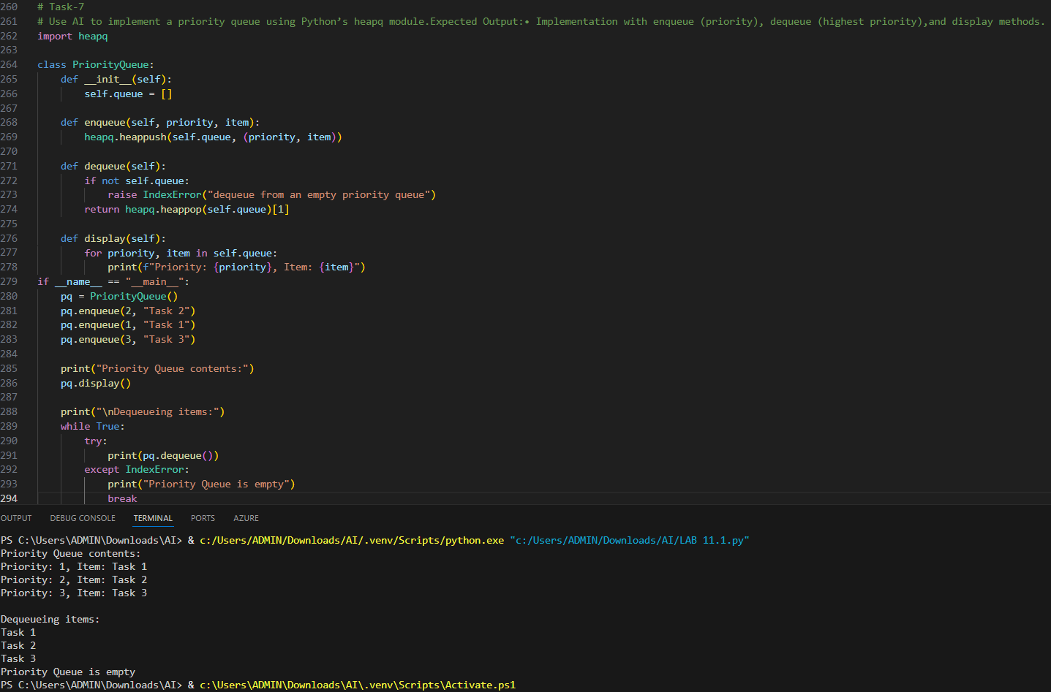  Task Description #8 – Deque  Task: Use AI to implement a double-ended queue using collections.deque.  Sample Input Code:  class DequeDS:  pass  Expected Output:  - Insert and remove from both ends with docstrings.  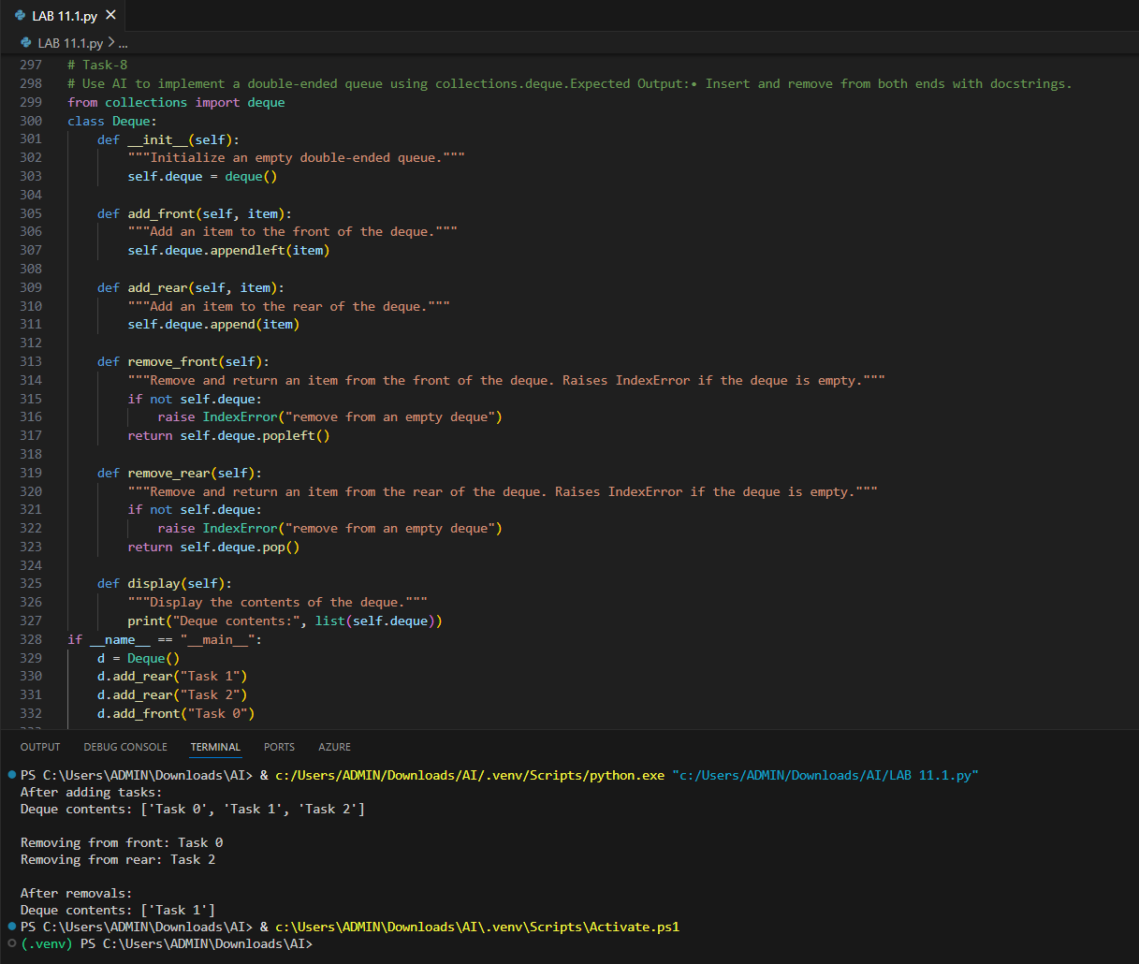  Task Description #9 Real-Time Application Challenge – Choose the Right Data Structure  Scenario:  Your college wants to develop a Campus Resource Management System that handles:  - Student Attendance Tracking – Daily log of students entering/exiting the campus.  - Event Registration System – Manage participants in events with quick search and removal.  - Library Book Borrowing – Keep track of available books and their due dates.  - Bus Scheduling System – Maintain bus routes and stop connections.  - Cafeteria Order Queue – Serve students in the order they arrive.  Student Task:  - For each feature, select the most appropriate data structure from the list below:  - Stack  - Queue  - Priority Queue  - Linked List  - Binary Search Tree (BST)  - Graph  - Hash Table  - Deque  - Justify your choice in 2–3 sentences per feature.  - Implement one selected feature as a working Python program with AI-assisted code generation.  Expected Output:  - A table mapping feature → chosen data structure → justification.  - A functional Python program implementing the chosen feature with comments and docstrings.  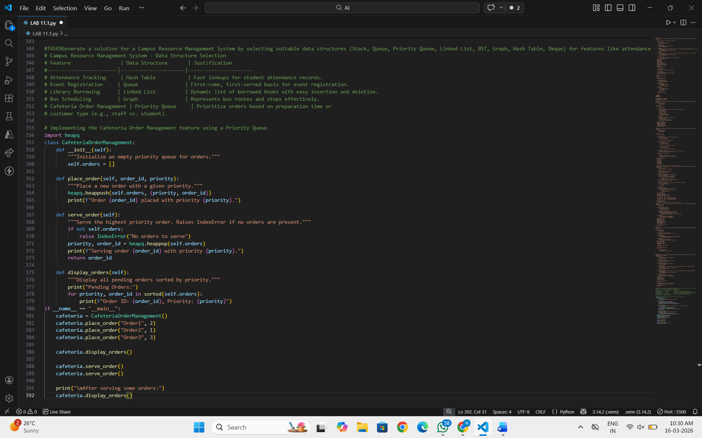  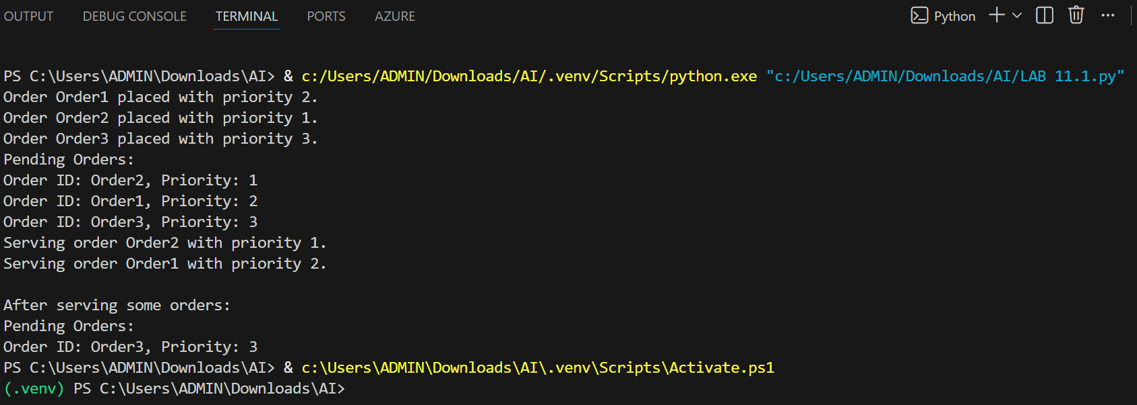  Task Description #10: Smart E-Commerce Platform – Data Structure Challenge  An e-commerce company wants to build a Smart Online Shopping System with:  - Shopping Cart Management – Add and remove products dynamically.  - Order Processing System – Orders processed in the order they are placed.  - Top-Selling Products Tracker – Products ranked by sales count.  - Product Search Engine – Fast lookup of products using product ID.  - Delivery Route Planning – Connect warehouses and delivery locations.  Student Task:  - For each feature, select the most appropriate data structure from the list below:  - Stack  - Queue  - Priority Queue  - Linked List  - Binary Search Tree (BST)  - Graph  - Hash Table  - Deque  - Justify your choice in 2–3 sentences per feature.  - Implement one selected feature as a working Python program with AI-assisted code generation.  Expected Output:  - A table mapping feature → chosen data structure → justification.  - A functional Python program implementing the chosen feature with comments and docstrings.  c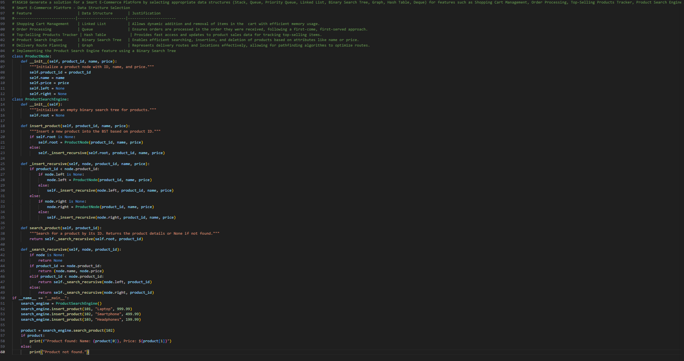 |  |  |  |  | Week6 -Monday

